Sprint Review Report Template

<Project Name>

Sprint Review Report

<Sprint #>

<Version>

<Date>

<Team Member Names>

Software Engineer

Prepared for

<Course and Section Number >

<Semester and Year >

<Institution >

# Revision History

|  |  |  |  |
| --- | --- | --- | --- |
| **Date** | **Description** | **Author** | **Comments** |
| <date> | <Version 1> | <Your Name> | <First Revision> |
|  |  |  |  |
|  |  |  |  |
|  |  |  |  |

# Document Approval

The following Software Requirements Specification has been accepted and approved by the following:

|  |  |  |  |
| --- | --- | --- | --- |
| **Signature** | **Printed Name** | **Title** | **Date** |
|  | <Your Name> | Software Eng. |  |
|  |  |  |  |
|  |  |  |  |

**Table of Contents**

Revision History ii

Document Approval ii

1. Introduction 1

2. Specific Goals 1

3. AnalTICS 2

4. CONCLUSION 3

# 1. Introduction

Brief overview of the Sprint. It should include high level goals and objectives of the sprint. It should include high level product features planned for the sprint. It should mention how many stories and points were planned for the Sprint and how many of those were implemented. It should also highlight overall progress of project and it should provide a sense of overall project direction, success, and challenges.

# 2. Specific Goals

*This section should include specific stories planned for the Sprint:*

***2.1 Story Name & Number***

*What is the name and unique number of the story*

***2.1.1 Story Description:***

*Provide a short description of the story*

***2.1.2 Story Acceptance Criterion***

*Briefly describe the acceptance criterion*

***2.1.3 Story Dependencies***

*Mention whether the story is dependent on the completion of other stories*

***2.1.4 Story Challenges***

*Briefly outline any challenges or difficulties faced in implementing the story. Challenges may be of technical nature or resource related.*

***2.1.5 Story Assigned to***

*Who has been tasked to implement the story*

***2.1.6 Story Points***

*How many points have been assigned to the story*

***2.1.7 Status: Completed or not***

*Provide the status of the story, whether it was completed or not. If not, then what is Plan of Action (POA) for it.*

***2.2 Story Name & Number***

*What is the name and unique number of the story*

***2.2.1 Story Description:***

*Provide a short description of the story*

***2.2.2 Story Acceptance Criterion***

*Briefly describe the acceptance criterion*

***2.2.3 Story Dependencies***

*Mention whether the story is dependent on the completion of other stories*

***2.2.4 Story Challenges***

*Briefly outline any challenges or difficulties faced in implementing the story. Challenges may be of technical nature or resource related.*

***2.2.5 Story Assigned to***

*Who has been tasked to implement the story*

***2.2.6 Story Points***

*How many points have been assigned to the story*

***2.2.7 Status: Completed or not***

*Provide the status of the story, whether it was completed or not. If not, then what is Plan of Action (POA) for it.*

*…*

*…*

# 3. Analytics

## 3.1 Sprint/Product Burndown Chart (sample chart shown below)

### Image result for sprint velocity chart IMAGE

## 3.2 Sprint Velocity (sample chart shown below)

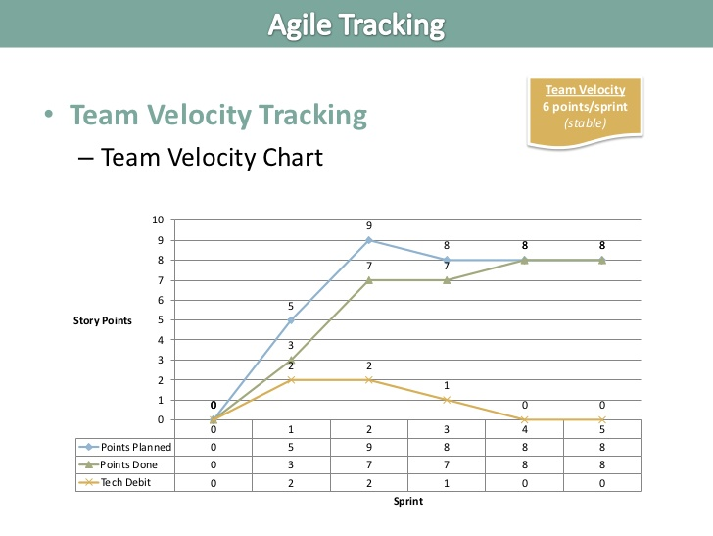

# 4. Conclusion